2D ANIMATION

LAB ASSIGNMENT 6

***NAME: PREETI RACHEL JASPER***

***REG NO: 17BCS0003***

1. CONTENT AWARE FILL
2. CLONE STAMP
3. LENS FLARE
4. RAIN EFFECT
5. HIGHLIGHT JEWELLERY IN AN IMAGE

CLONE STAMP

* With the Clone Stamp tool selected, position the cursor over the area you want to clone and then Alt-click (Windows) or Option-click (Mac) to define the clone source.
* Position the cursor over the area where you want to paint the cloned pixels and then start painting.
* Click the second Clone Source icon at the top of the Clone Source panel.
* Alt-click (Windows) or Option-click (Mac) somewhere else on the page to define a second clone source

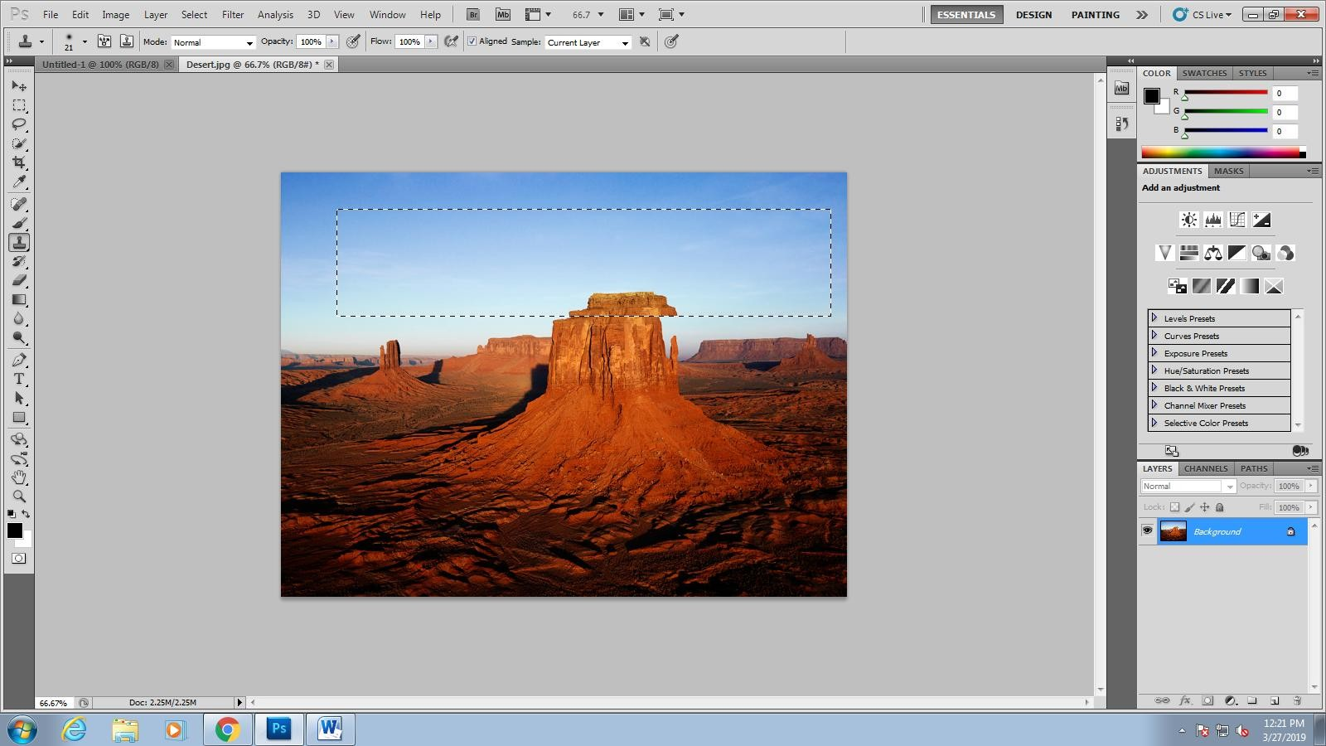

CONTENT AWARE

* Open an image in Photoshop. Use any selection tool to select a part of the image you want to fill.
* Choose Edit > Content-Aware Fill.
* Photoshop launches the Content-Aware Fill workspace.
* Within the Content-Aware Fill workspace, the document window displays the default sampling area as an overlay mask over the image.

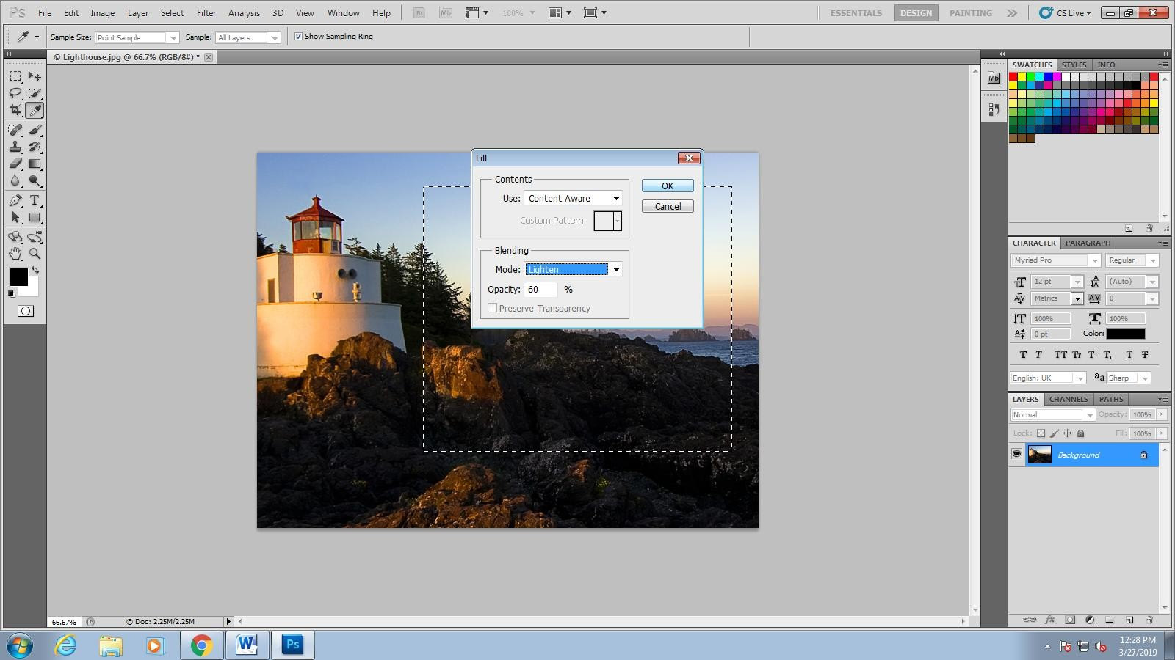

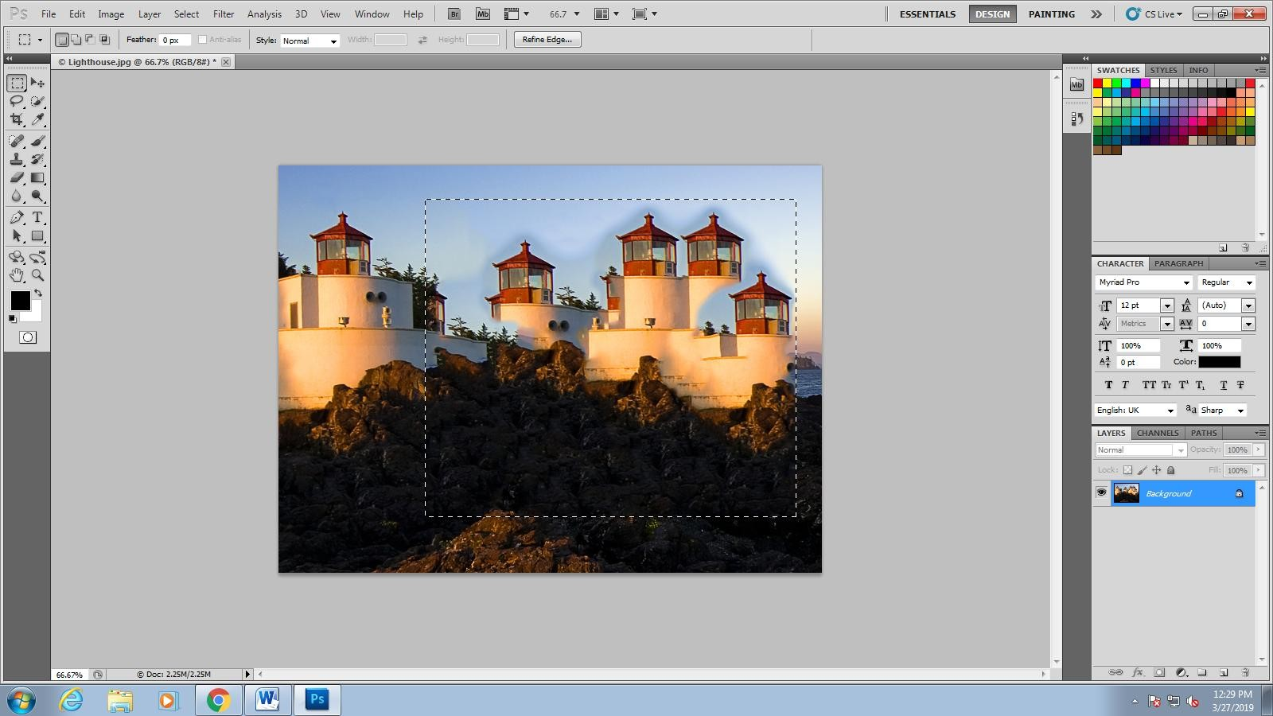

LENS FLARE

Step 1: Apply The Lens Flare Filter. ...

Step 2: Undo The Lens Flare. ...

Step 3: Add A New Blank Layer. ...

Step 4: Fill The New Layer With Black. ...

Step 5: Re-Apply The Lens Flare Filter. ...

Step 6: Change The Layer Blend Mode To Screen. ...

Step 7: Adjust The Color Of The Lens Flare.

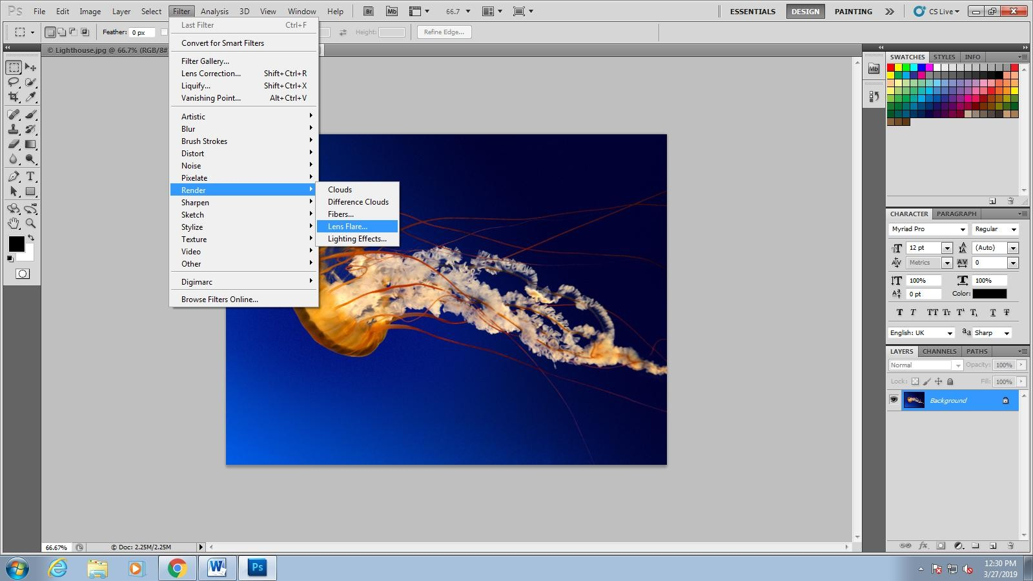

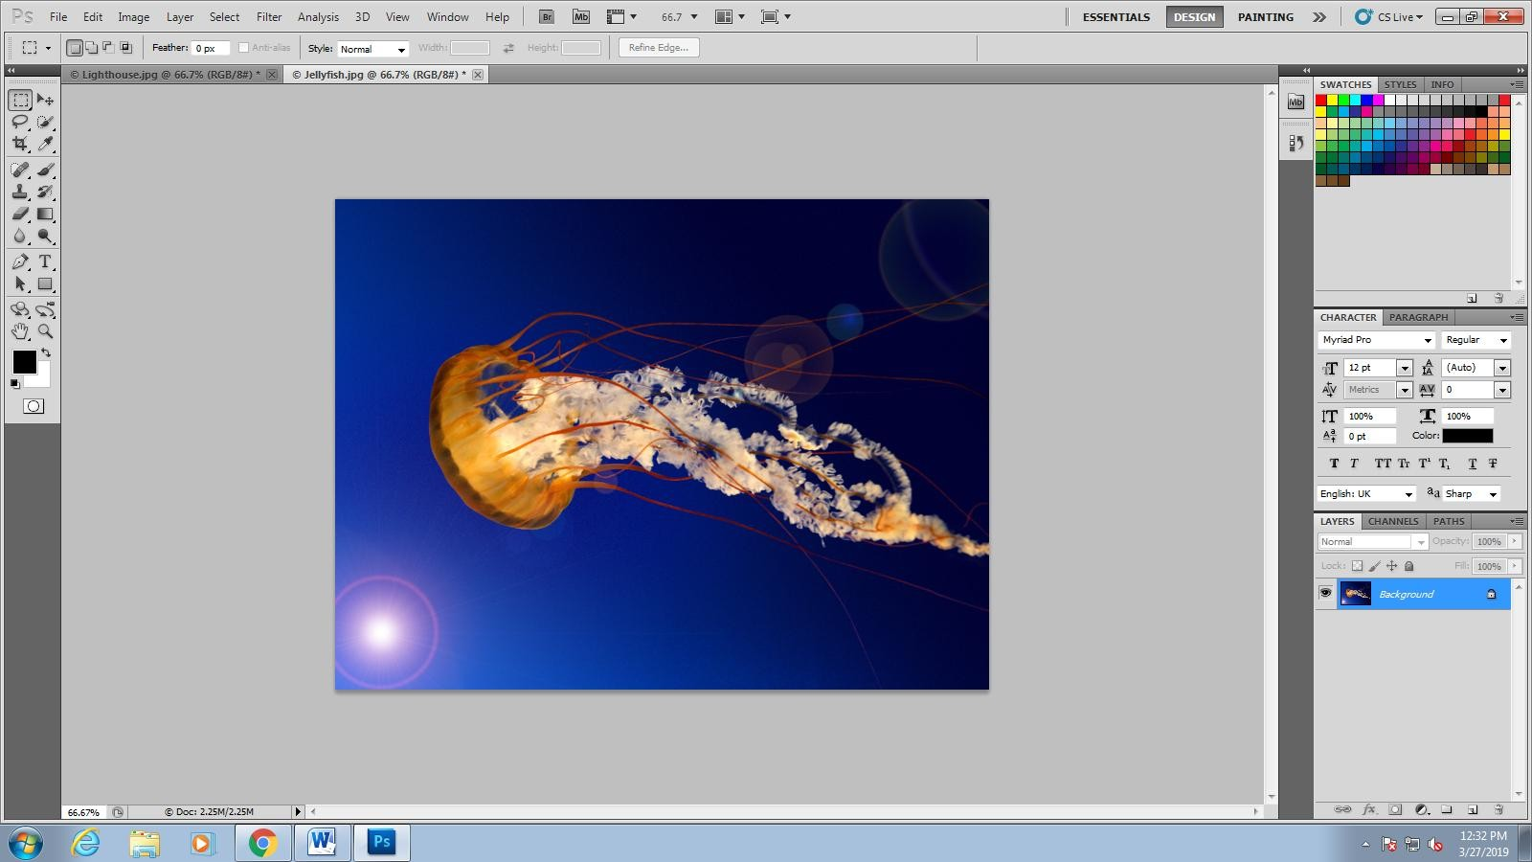

RAIN EFFECT

* Step 1: Duplicate The Background Layer
* Step 2: Add Some Extra Canvas Space Around The Image
* Step 3: Add A New Blank Layer.
* Step 4: Fill The New Layer With Black
* Step 5: Add Noise To The Layer
* Step 6: Apply The Gaussian Blur Filter To The Noise
* Step 7: Add A Levels Adjustment Layer
* Step 8: Reduce The Amount Of Noise And Increase Its Contrast
* Step 9: Apply The Motion Blur Filter To The Noise
* Step 10: Re-Adjust The Black And White Sliders In Levels As Needed
* Step 11: Crop Away The Extra Canvas Space
* Step 12: Change The Blend Mode Of The Noise Layer To "Screen"

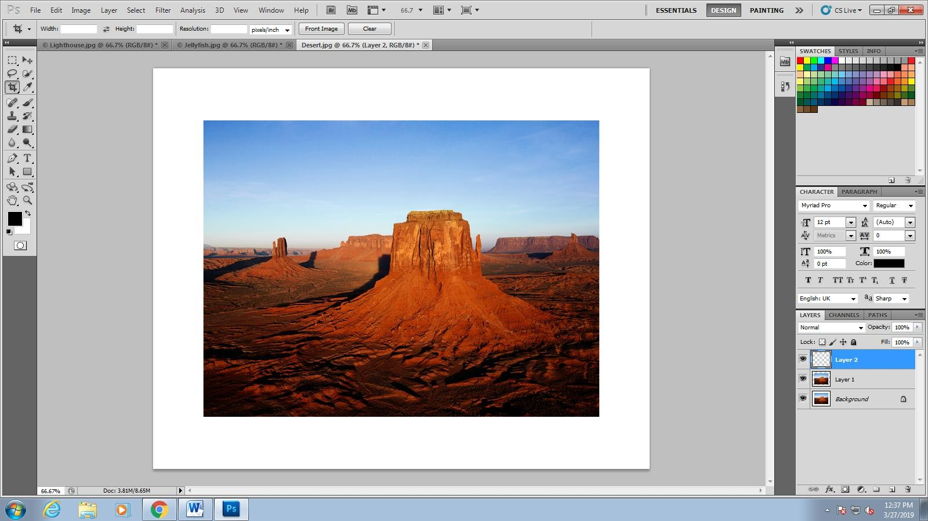

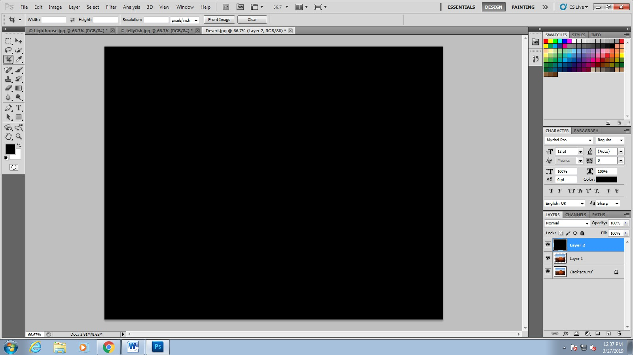

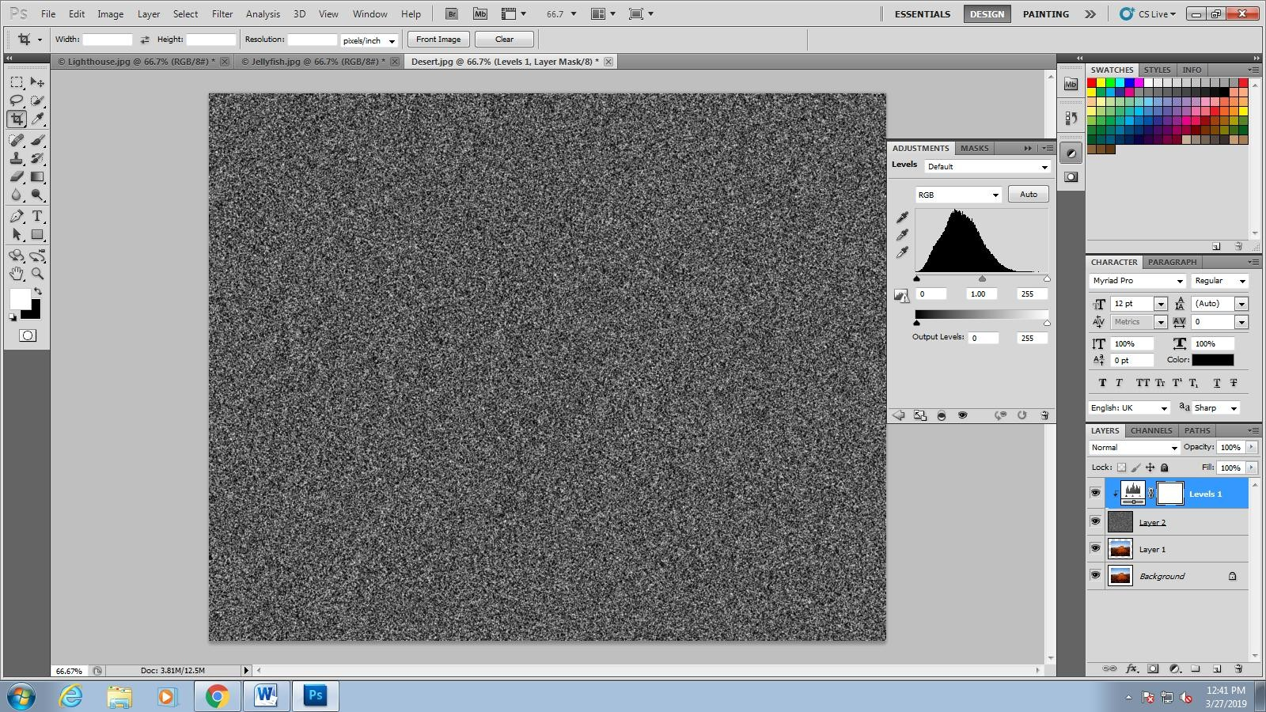

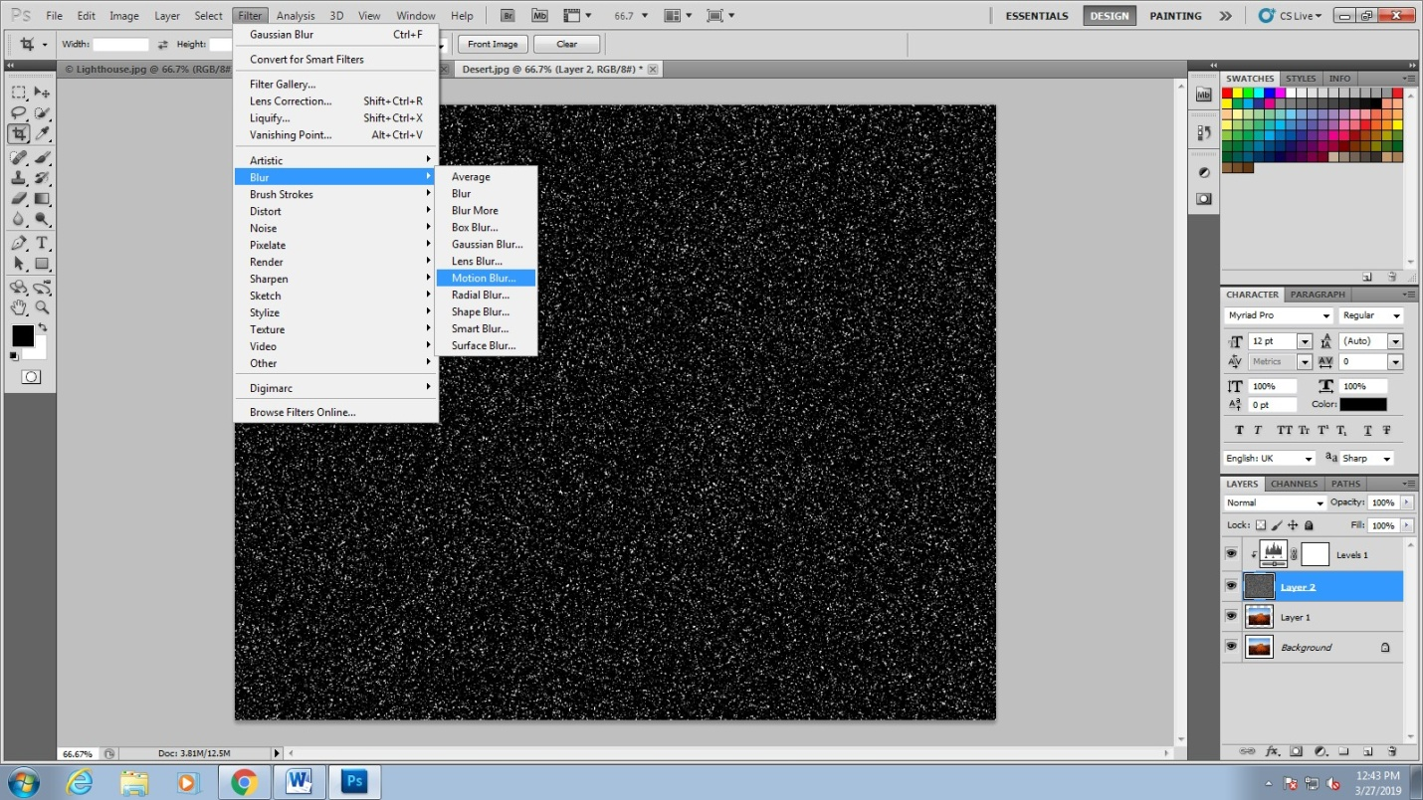

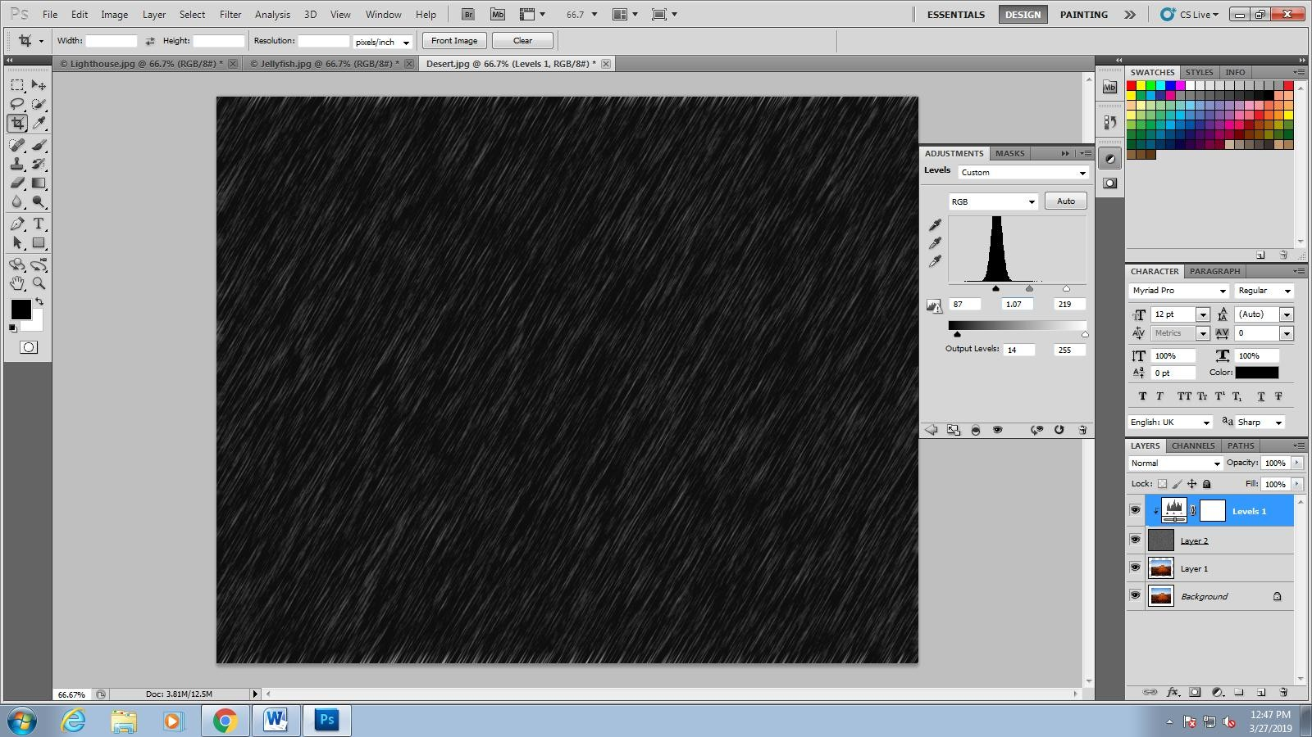

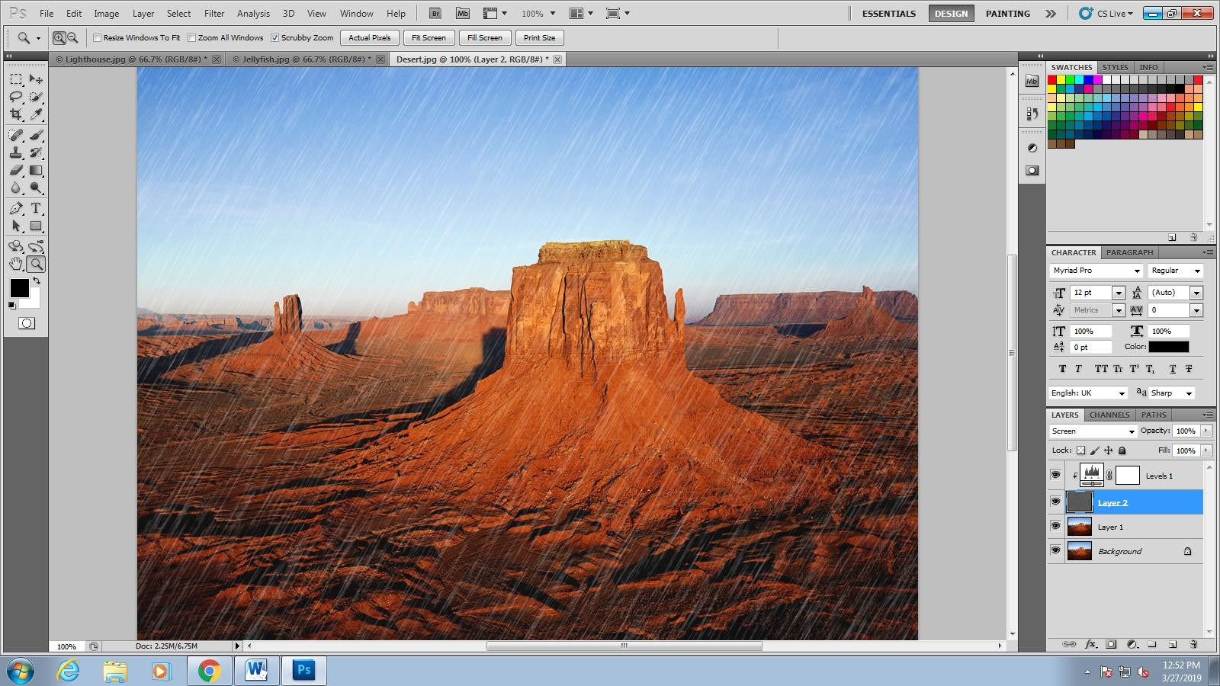

HIGHLIGHT JEWELLERY IN AN IMAGE

* Open Adobe Photoshop
* Click on "File" on the menu bar and then select "open" option.
* Now "open" window will open up, select the desired photo and click on "open" button.
* The photo you have selected will appear in the Photoshop. Now look for "layers" window in Photoshop, if you can't found it click on "window" on menu bar and select "layers" or use "F7" key.
* In the layers window click on layers tab and right click on image and select "duplicate layer". Now "Duplicate Layer" window will open up, in that window give name ad "duplicate1" and click ok. This will create duplicate layer of the first image with the name "duplicate1" as shown below.
* first duplicate layer
* Now select "duplicate1" layer and then select "Image" from menu bar and click on "Adjustments" and then "Desaturate". You can also use short cut Shift+Ctrl+U to desaturate photo. Now your photo will appear as black and white photo.
* Now again create duplicate of "duplicate1" layer by right clicking and selecting "duplicate layer" option. Name the new duplicate layer as "duplicate2".
* Now you have to make "duplicate2" layer as a invisible layer, this can be done by clicking on the eye icon which is present on the left side of the "duplicate2" layer. After making "duplicate2" layer as invisible, layers window looks like below.
* Invisible layer
* Next step is to create a vector mask to the"duplicate1" layer, to do this first select "duplicate1" layer and click on vector mask option which is available in the layers window ( see the image below ). By doing these steps vector mask of "duplicate1" layer will be created.
* vector mask
* Now click on "duplicae1" layer and select "Image" from menu bar and click on "Apply Image" option. Now apply image window will open up, do not change any options and click on "ok" button.
* Now select "duplicate1" layer and click on "Filter" option available on menu bar. Now drop down menu will appear, select "stylize" and then select "Find Edges" option. Now photo looks like this.
* find edges
* Now select "duplicate2" layer and select "Eraser" tool and then erase the area of the photo which you want to highlight. Here in this photo I want to highlight jewellery, So I have erased the area where jewellery appears. Now photo looks like this.
* Before enhancement
* Now Select File and click on Save and save your image in JPEG format.

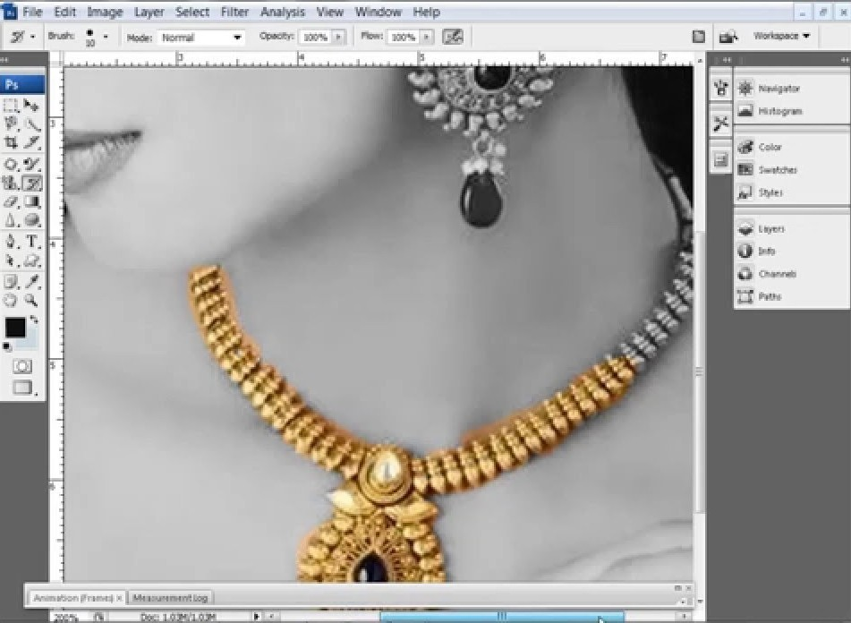

**THANK YOU!**